**Analysis of TLC Trucking**

**Executive Summary**

In this report, we use the i* modeling methodology to carefully examine the current situation at a truck rental organization known as TLC Trucking. We analyze the setting from both the client’s and company’s perspectives, then propose two transformation alternatives with the aid of SR and SD models along with the comparison of their alternatives. Furthermore, we analyze the proposed transformative ideas with the help of two separate goal models created using innovation and automation ideas proposed previously. These models help us to identify the relevant soft-goals and determining how each alternative contributes to these criteria. Lastly, the paper compares the use of i* and other process modeling notations. Highlights of potential changes are presented throughout the analysis of TLC Trucking ordering process. Areas of improvements considered include reducing overall process time, improving the flow of data and their dependencies, and minimizing labour-intensive tasks performed by stakeholders.

# Table of Contents and List of Figures

**Table of Contents and List of Figures** **3**

**1. Context of the Study** **5**

Organizational Objectives and Stakeholder Goals 5

**2. Detailed Analysis of As-Is Situation** **6**

The Process and the Soft Goals 10

**3. Detailed Analysis of To-Be Alternatives** **13**

**3.1 First Alternative for Detailed Analysis** **13**

**3.2 Detailed Analysis of the First Alternative Using i\*** **13**

Overall SD analysis - Actors’ Relationships, Dependencies, Tasks, Goals 14

Eliminating Manual Work 14

Fast response 15

Client satisfaction 15

Workability 17

Viability 18

**3.3 Second Alternative for Detailed Analysis** **19**

The Process 19

**3.4 Detailed Analysis of the Second Alternative Using i\*** **20**

SD Representation of 2nd Transformation Alternative 20

Analysis of SD Diagram 20

SR Representation of 2nd Transformation Alternative 25

**4. Comparison of the Two Alternatives** **27**

**5. Comparison of Process Alternatives from Assignment 2** **28**

**5.1 Description of Process Automation Alternatives** **28**

**5.2 Goal Model-Based Analysis of Automation Alternatives** **29**

**5.3 Description of Process Innovation Alternatives** **30**

**5.4 Goal Model-Based Analysis of Innovation Alternatives.** **31**

**6. Comparison of i* and Process Modeling Techniques** **33**

**6.1 Comparison of Techniques in the Context of the Case Study** **33**

**6.2 Strengths and Weaknesses of i* in the General Case** **35**

Strengths 35

Weaknesses 35

**A Note On Why We Chose This Topic** **36**

**7. References** **37**

Table of Figures

Figure 1.0: As-Is SD .................................................................................................................................... 7

Figure 1.1: As-Is SD .................................................................................................................................... 8

Figure 1.2: As-Is SD .................................................................................................................................... 9

Figure 2.0: As-Is SR ....................................................................................................................................10

Figure 2.1: As-Is SR ....................................................................................................................................11

Figure 2.2: As-Is SR ................................................................................................................................... 12

Figure 3.0: To-Be Alternative One SD ....................................................................................................... 13

Figure 3.1: To-Be Alternative One SD vs As-Is SD................................................................................... 14

Figure 3.2: To-Be Alternative One SD........................................................................................................ 15

Figure 3.3: To-Be Alternative One SD vs As-Is SD .................................................................................. 16

Figure 3.4: To-Be Alternative One SR ....................................................................................................... 16

Figure 3.5: To-Be Alternative One SR ....................................................................................................... 17

Figure 3.6: To-Be Alternative One SR ....................................................................................................... 18

Figure 3.7: To-Be Alternative Two SD ...................................................................................................... 20

Figure 3.8: To-Be Alternative Two SD ...................................................................................................... 21

Figure 3.9: To-Be Alternative Two SD....................................................................................................... 22

Figure 4.0: To-Be Alternative Two SD ...................................................................................................... 23

Figure 4.1: To-Be Alternative Two SD ...................................................................................................... 23

Figure 4.2: To-Be Alternative Two SD ...................................................................................................... 24

Figure 4.3: To-Be Alternative Two SD ...................................................................................................... 24

Figure 4.4: To-Be Alternative Two SD ...................................................................................................... 25

Figure 5.0: To-Be Alternative Two SR ...................................................................................................... 25

Figure 5.1: To-Be Alternative Two SR ..................................................................................................... 26

Figure 5.2: To-Be Alternative Two SR ..................................................................................................... 27

Figure 6.0: Goal Model of Process Automation Analysis ......................................................................... 29

Figure 7.0: Goal Model of Process Innovation Analysis ........................................................................... 31

# 1. Context of the Study

TLC Trucking focuses on ongoing restructuring of company initiatives by continuously identifying client demands to provide client satisfaction. Improving communication with clients is a long-term goal for the company, along with improving social responsibility by building a strong reputation in the industry, and its effort to serve diverse markets. As a market leader in an increasingly competitive and concentrated Canadian retail industry, this organization deals with various obstacles on a daily basis. TLC Trucking on average receives approximately 800 client requests per day. Each client request takes approximately three hours to process (CDM and Transport contribution combined). This organization, along with industry peers, continues to use manual methods for work related services. This is a clear opportunity for improvement.

The truck ordering process includes actors, physical objects, and information objects. Actors are the employees in various departments, the database management systems, and the physical and information objects, which include documents such as application forms and the electronic records that store data on the client and trucking inventory. The process examined in this analysis is cross-departmental. The stakeholders involved are two departments within TLC Trucking: the Transportation Department (TD) responsible for the delivery and maintenance of the trucks in the system, and the Central Data Maintenance department (CDM) that has access to client information.

## Organizational Objectives and Stakeholder Goals

The lack of automation for this company results in time-consuming processes that hamper productivity. For example, the existing process relies heavily on manual checks done by the CDM to verify the incoming client data. Transport has to manually re-enter submitted requests into an internal software to process truck orders. The current procedures taken by the client to submit their order request is demanding and prone to errors. Inadequate understanding of how data should flow from the beginning to the end of the process leads to additional effort by the TLC Trucking departments. The transport department sends and receives information from the client, when the CDM’s main role is to act as a liaison between the client and the organization. Verifying, validating, and checking data availability are critical tasks in the current process. Roles are poorly identified and understood while executing these tasks, resulting in a drain on the knowledge and skills each department has accrued. The current process doesn‘t align with the client's goals which includes fast process, privacy, and good communication.

The new transformational ideas can achieve the clients’ and the company's goals. The CDM can be replaced by automated work process and the transportation work can be minimized. With implementation of database management systems, the flow of data can be improved throughout the organization, ensuring accuracy in information exchange between actors. Implementing new, digital solutions will lead to a reduction in wait time, save resources, accelerate the process and make it easier and faster for the clients to receive information about truck availability.

# 2. Detailed Analysis of As-Is Situation

The rental process starts when a client accesses the website and downloads the rental application form, prints it and completes it manually. The client scans the application and sends it to the CDM by mail, e-mail or in-person. The CDM then checks the information and records what the client wants and sends the completed application to the TD. The TD checks whether the trucks requested by the clients are available and then sends the availability of the trucks alongside the quote.

To better understand the process and network of dependency relationships among the actors, we have created a Strategic Dependency (SD) model. This will help us analyze the opportunities and vulnerabilities, and see if the process aligns with the company's and the client's’ goals, as well as help us find ways to improve the process. (Figure 1.0: As-Is SD)

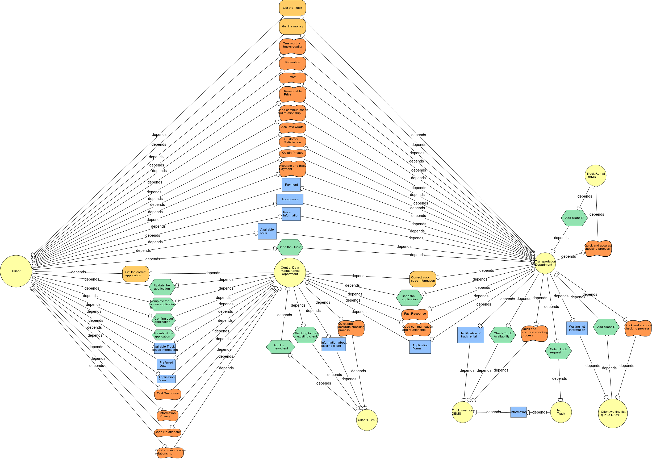

*Figure 1.0: As-Is SD*

The main actors involved in the process are the clients, CDM, and TD. As mentioned, the process starts when the clients manually send the application to the CDM. This can be a big issue, because the applications and the emails have a chance to be lost. Handwritten applications also risk being misread. After the application is confirmed by the CDM, clients are searched for manually in the database to know if they are existing or new clients. (Figure 1.1: As-Is SD)

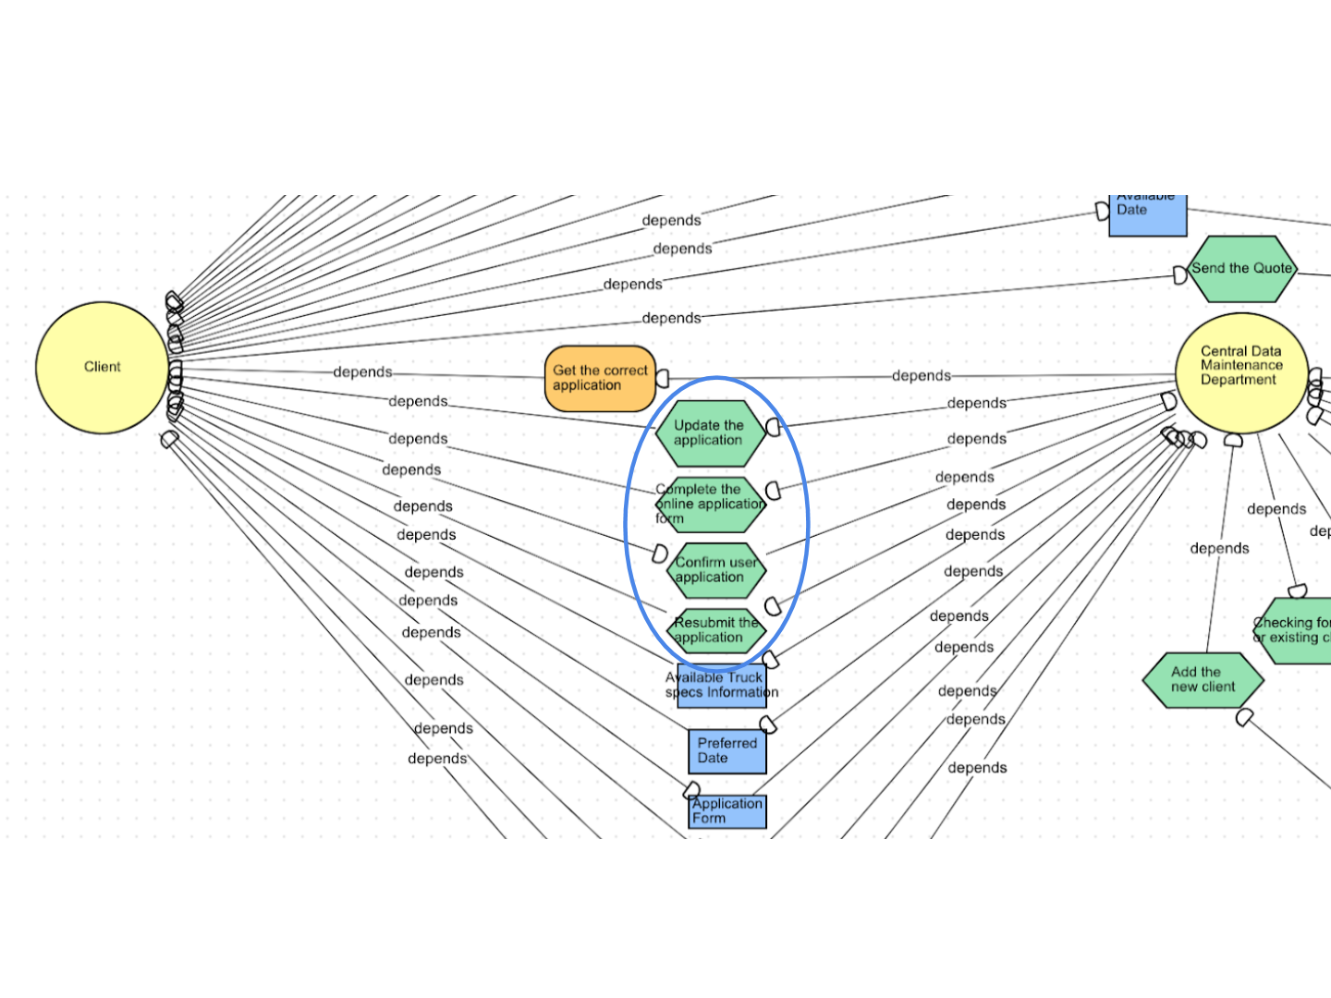

*Figure 1.1: As-Is SD*

The CDM then types the application in an internal company document and sends it to TD. The TD depends on the information in the application sent by the CDM and uses this information to checks manually in the databases to see if the truck specs and trucks requested by the clients are available. The database depends on the information submitted by the TD and informs the TD about truck availability. Once the truck specs are confirmed, TD looks manually in the truck inventory databases to see if the trucks are available. If available, client Id is added to the trucks and once they are cleared from the waiting list. TD contacts them and provides a date to pick up the truck.

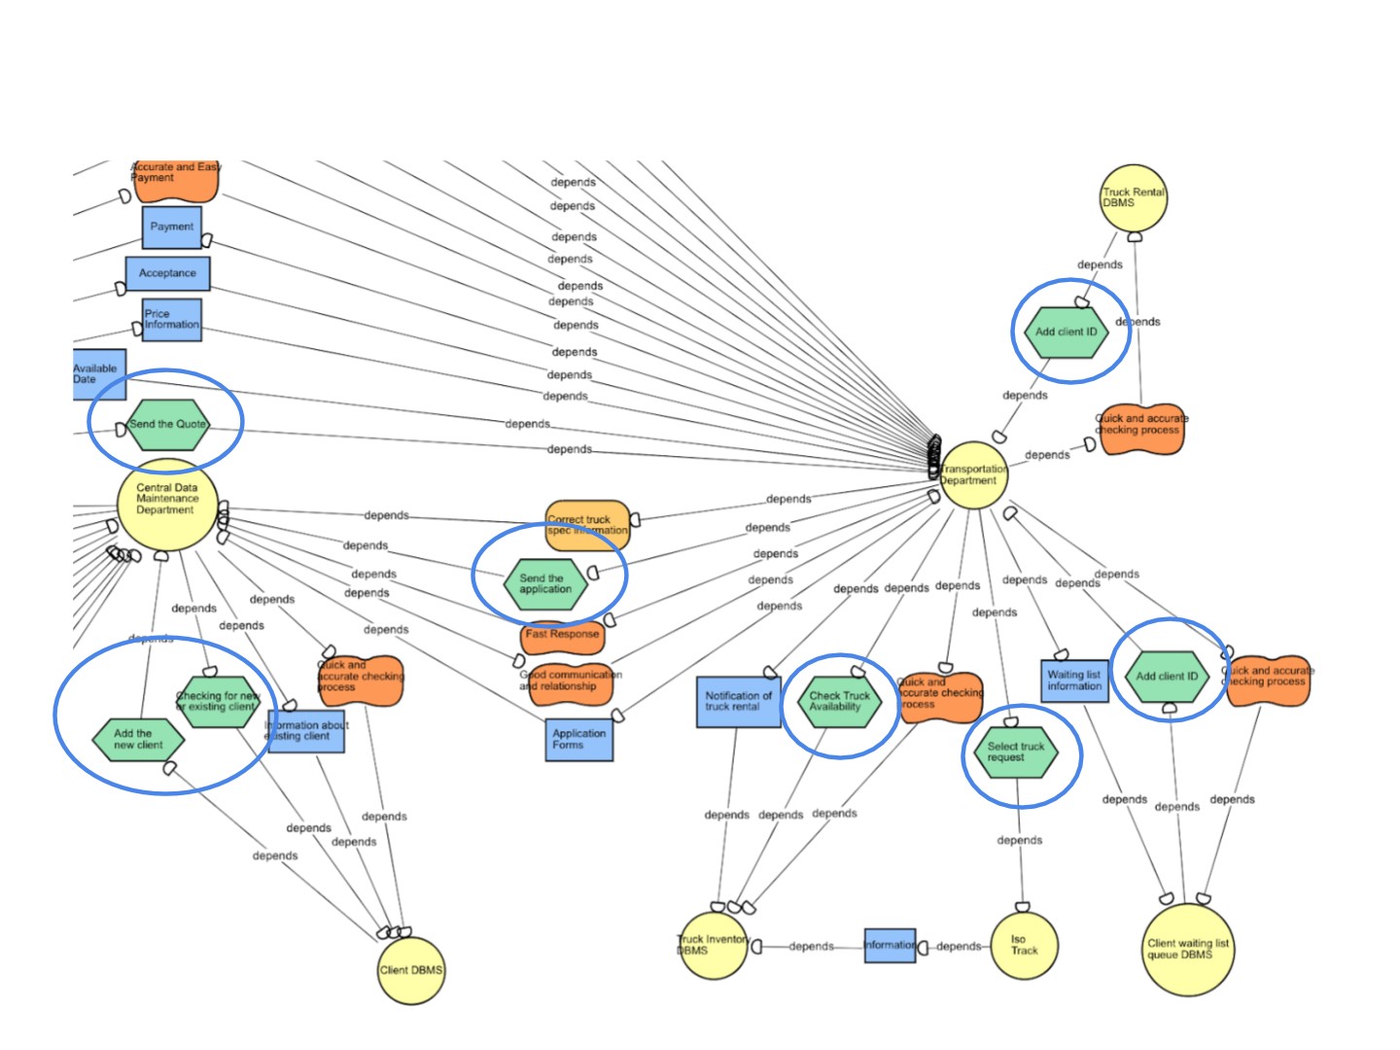

*Figure 1.2: As-Is SD*

The SD helped us understand the dependencies among the actors and the task performed by them. CDM depends on the client to send the correct application and information.The TD depends on CDM to send the correct application to see if the truck specs are available or not and see if the trucks are available. The client depends on the information sent by TD to determine their acceptance of the offer.(Figure 1.2: As-Is SD)

The CDM’s main goal is to get the correct application and send it to the TD. The TD’s main goal is to provide the client with the truck they requested,receive the money from them and satisfy the client. SD model helped us understand the softgoals better. The client soft goals include, profit/cost, good and fast service, convenience, privacy and security and also good communication with the company.The CDM and TD soft goals are communication and information privacy. The SD helped us find the process limitations, which include slow manual work, a long approval wait period for clients, and inaccurate flow of work hurting the clients’ privacy. After creating the SD model, we created the SR model to deepen our understanding of strategic actors’ reasoning about the process and the relationships between the company and the client. We designed the SR based on the company and clients’ soft goals to show what makes them choose TLC over others. We represented each actor in a separate circle to see how they work together to satisfy the goals and see the steps hurt the goals so that we can improve them. (Figure 2.0: As-Is SR)

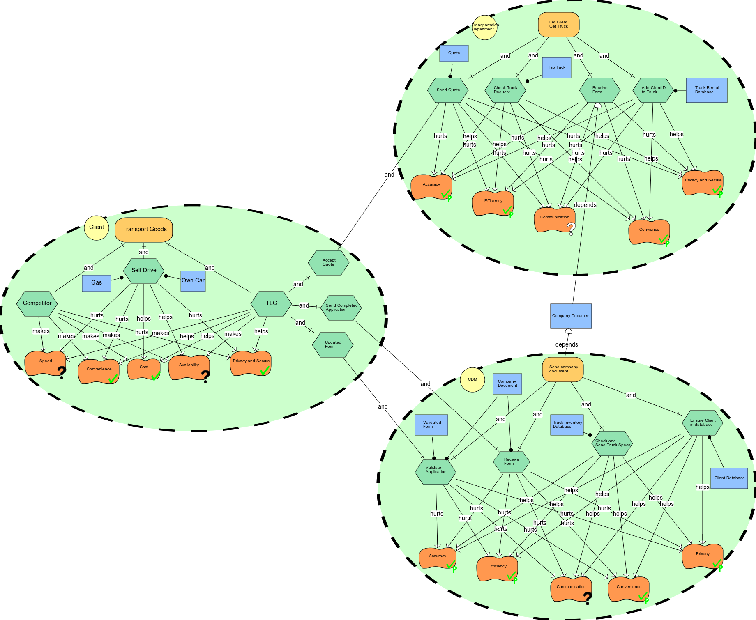*Figure 2.0 : As-Is SR*

## The Process and the Soft Goals

**CDM:** The tasks performed by the CDM in the process include form validation and ensure the clients are in the database. The process and the way these tasks are performed hurt the soft goals and is mainly because of the manual workflow. The process is not accurate because the work is done manually. The CDM checks the handwritten form and updates it in the database; any problem in the submitted data can affect the information in the database and therefore affect the accuracy of the process. The tasks done by the CDM also hurts the efficiency of the process. It takes a long time to verify the applications. Communication is hurt by the CDM process; the communication over email is slow and lots of information can be lost. Privacy is also affected in the process because of the manual paperwork due to which people can see the client’s private information. (Figure 2.1: As-Is SR)

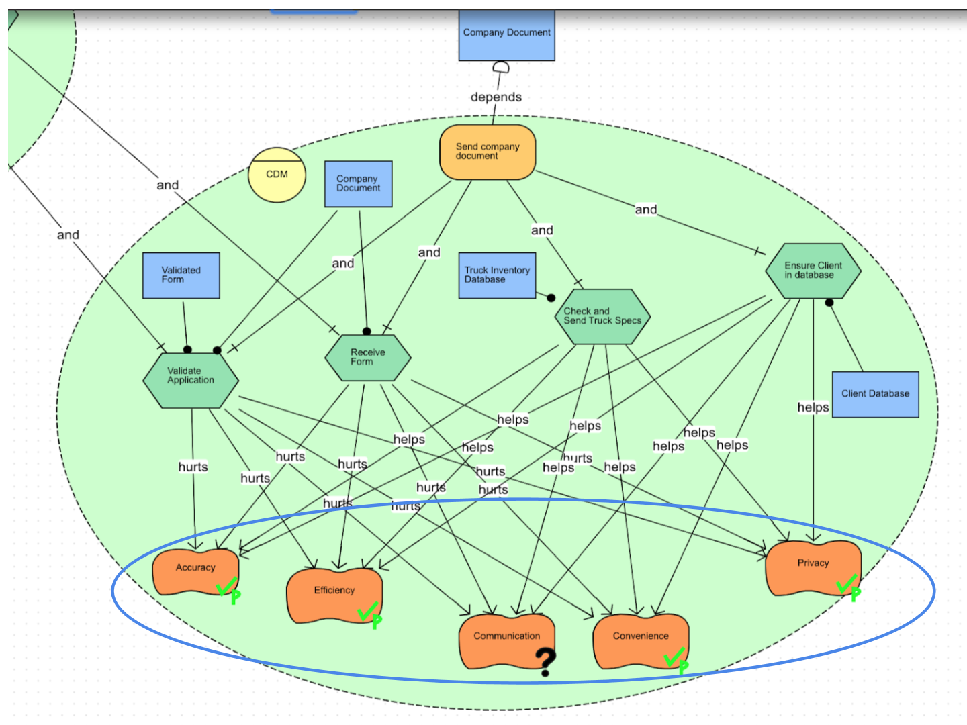

*Figure 2.1: As-Is SR*

**TD**: The tasks performed by the TD include checking the availability of the trucks, adding the client id to the trucks and sending the pick up date and quote to the clients. These tasks are also done manually in the process. Accuracy is hurt because of the manual work as some of the data can be lost or erroneous. Communication is hurt since the clients don’t hear from the TD until the truck is available and this process can take up to 2 weeks to complete; communication is also slow because of the manual exchange of information between the different departments. Efficiency is hurt, as it takes a long time to check for the truck availability in database. Privacy is hurt because the manual exchange of order information increases the risk of leaking client’s details. (Figure 2.2: As-Is SR)

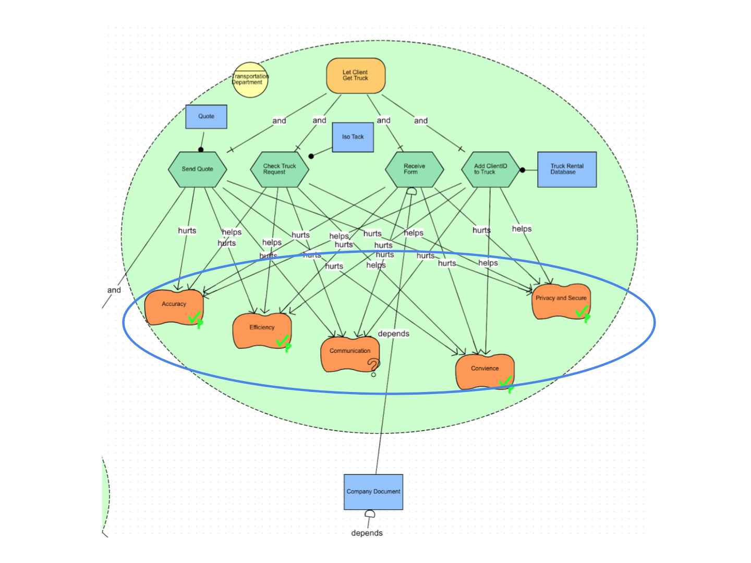

*Figure 2.2: As-Is SR*

Because of the bad process TLC loses new clients and only loyal clients place recurring orders. SR showed that all the softgoals needed by the clients including accuracy, convenience, privacy, communication, fast process and efficiency are not met and therefore we need to find a way to improve the process.

The SR helped us to find opportunities to improve the process which includes addition of tools to eliminate the manual work and make the process accurate and efficient. Addition of communication tools makes it easier for the clients and the departments to reach one another quickly. We can also find a way to eliminate the paperwork to improve accuracy, efficiency and save resources.

Although most of the soft goals required by the clients are not met, their hard goals are achieved. The clients receive good quality trucks for good price. The company’s hard goal is also met as they are able to make good profit and partially satisfy their clients.

# 3. Detailed Analysis of To-Be Alternatives

# 3.1 First Alternative for Detailed Analysis

As opposed to the existing business process where a client has to access TLC Trucking website and fill the online application form, the presence of a cloud-based app of TLC Trucking would make the process a lot easier and convenient to use.

The new app of TLC Trucking would have a new and separate section to display all the truck specifications including their size and capacity. All the specifications would be in the form of radio buttons that the client can select and thus, create their custom requirements. The compiled selection would then be submitted to TLC via the mobile app and the client would be notified about the estimated delivery date and quotation for the trucks when the list is submitted.

A major benefit of having this business model in place is that the process cuts down on the time that TLC normally takes to provide the quotation to the client. Here, the TLC does not have to query the database to identify the trucks and then calculate the quotation. Instead, the app already contains the quotations against the truck specifications. Furthermore, being a cloud-based app, it would be convenient for the client to use the TLC application from any place and place an order as opposed to having just one web application that may or may not render itself properly on a mobile.

# 3.2 Detailed Analysis of the First Alternative Using i*

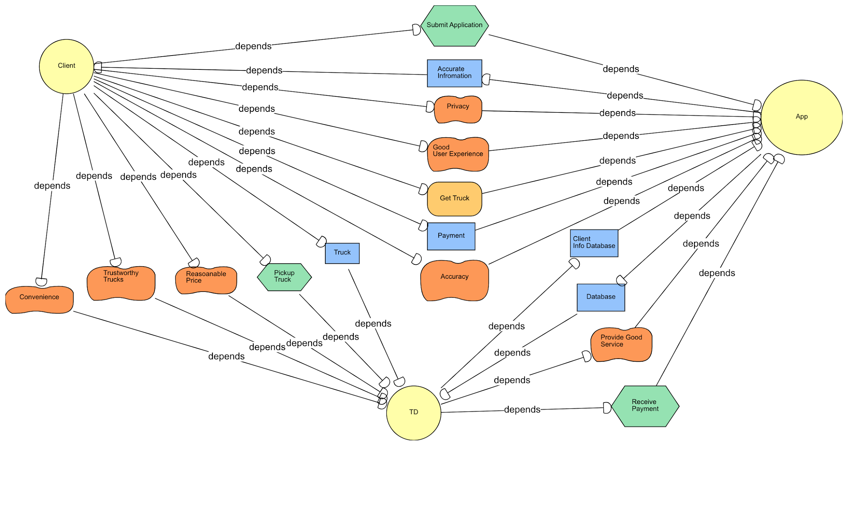

*Figure 3.0: To-Be Alternative One SD*

## Overall SD analysis - Actors’ Relationships, Dependencies, Tasks, Goals

In the first to-be alternative SD diagram (Figure 3.0), the main task between clients and app is to submit an online application through the online app. The app automatically validates the form and provides different functionalities including notification, checking trucks availability, estimated cost, and payment.

Once TD gets client’s payment, they prepare the trucks and the app sends a notification about the pick up time to the clients. Clients depend on TD to accomplish the task of truck pickup and to achieve soft goals including convenience, trustworthy trucks and reasonable price. The overall goal for clients is to get truck, which depends on both the app and TD.

## Eliminating Manual Work

Since TLC Trucking has so many database management systems in our As-is SD that manually store data, adding or updating a client requires a lot of steps. The app merges all the database management systems as an actor that carries out all the above processes to increase accuracy, as well as the clients’ information privacy. (Figure 3.1)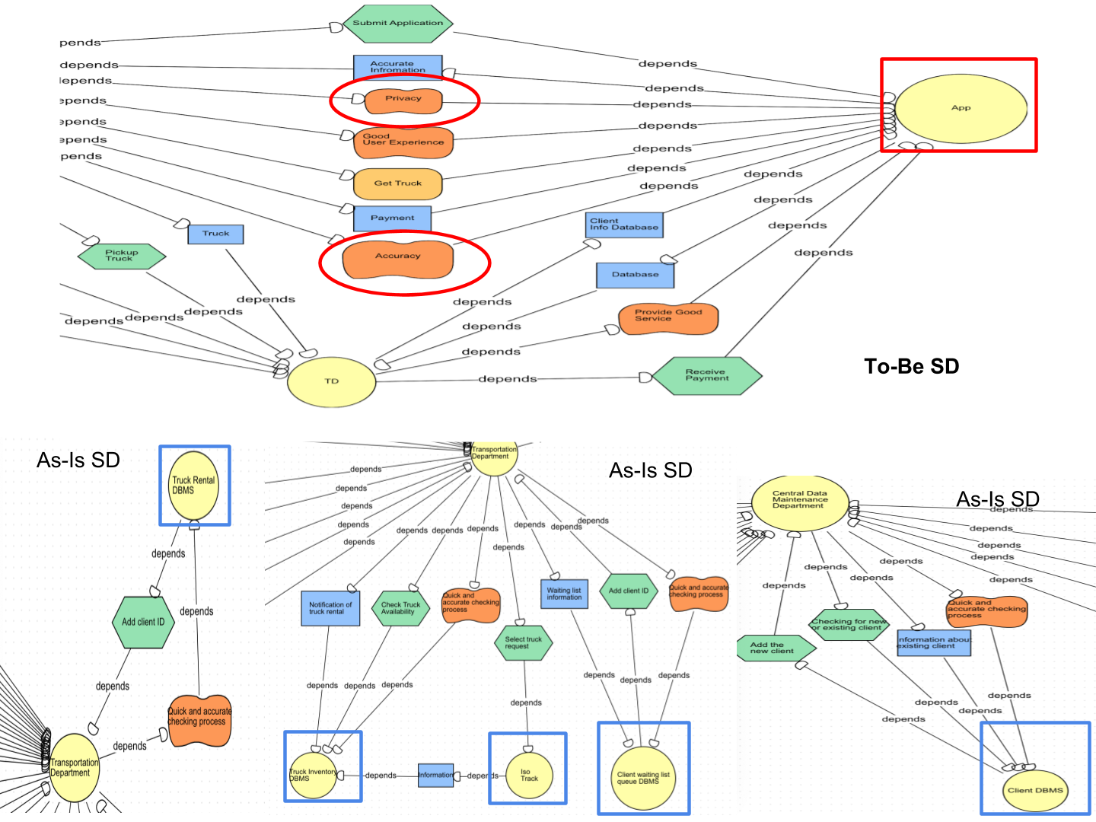

*Figure 3.1: To-Be Alternative One SD vs As-Is SD*

## Fast response

Instead of CDM checking the truck specs manually, the app can be linked directly to the database to see if trucks of a particular specification are available or not. If they are unavailable, a notification is given to the clients who can update their requests immediately. (Figure 3.2)

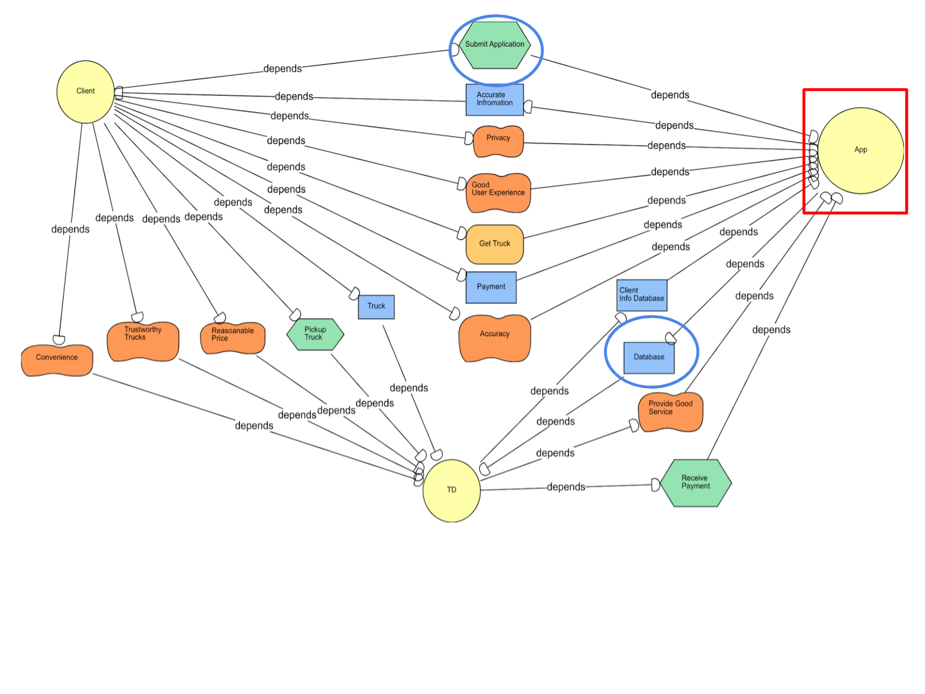

*Figure 3.2: To-Be Alternative One SD*

## Client satisfaction

The clients has to manually complete, update, and e-mail the application form to the CDM. As a result, the CDM has a lot of manual work and the clients have to wait for their approval. The app, on the other hand, allows the client to create an account where they can fill out their information and requests. The app will authenticate the order form. This will be automatically done without getting CDM to check their information manually. A notification will be provided to the clients in the case of missing information to ask them to complete the request. The app’s implementation prompts the TLC to merge the CDM and TD so that one department can validate the request through the app’s database and send the pickup truck notification to the client. Also, the client has a good user experience when using the app to order their truck. (Figure 3.3)

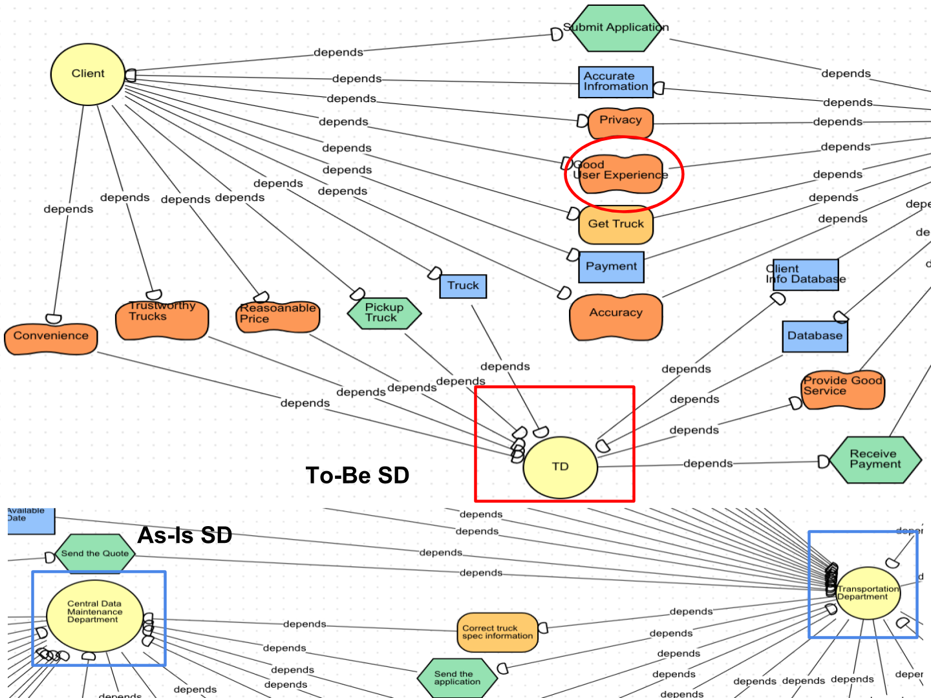

*Figure 3.3: To-Be Alternative One SD vs As-Is SD*

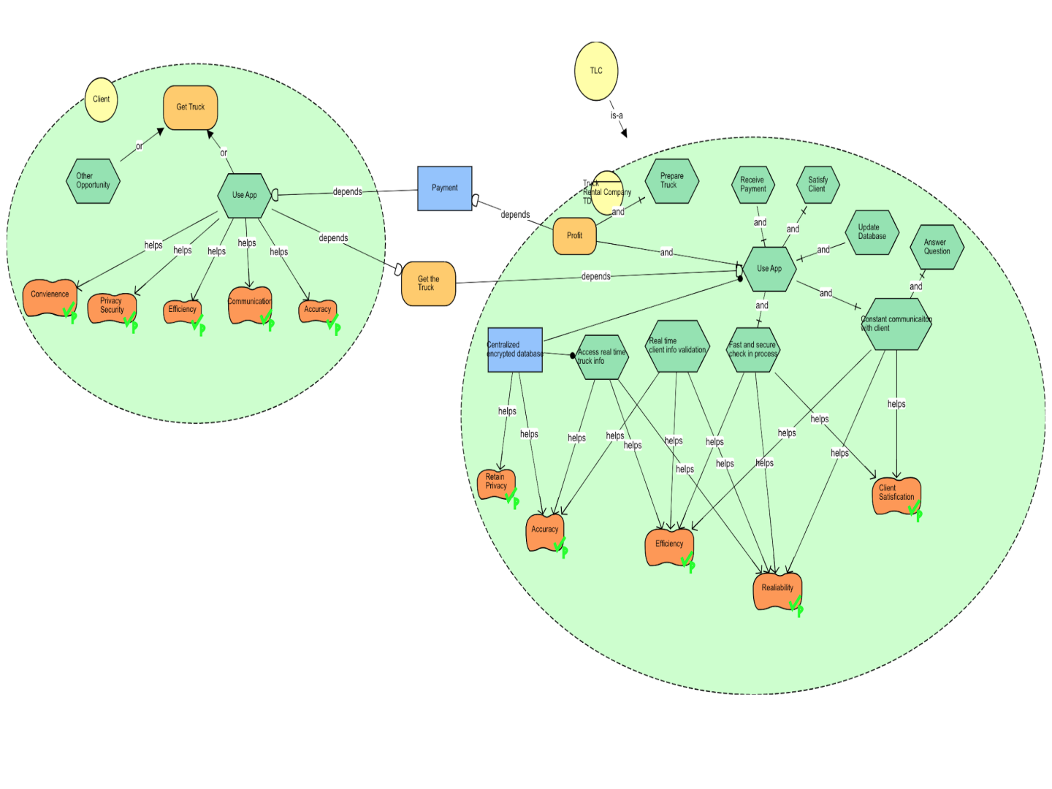

*Figure 3.4: To-Be Alternative One SR*

The clients have the ability to achieve their final goal (get the truck) through several subtasks including using the App, submitting online application, and checking availability and estimated prices, and finally sending the payment through the app. The app is straightforward to clients since they have the ability to determine immediately if they like the price through the app. The app also simplifies the ordering process (sending request, updating information, etc.) and resources. (Figure 3.4)

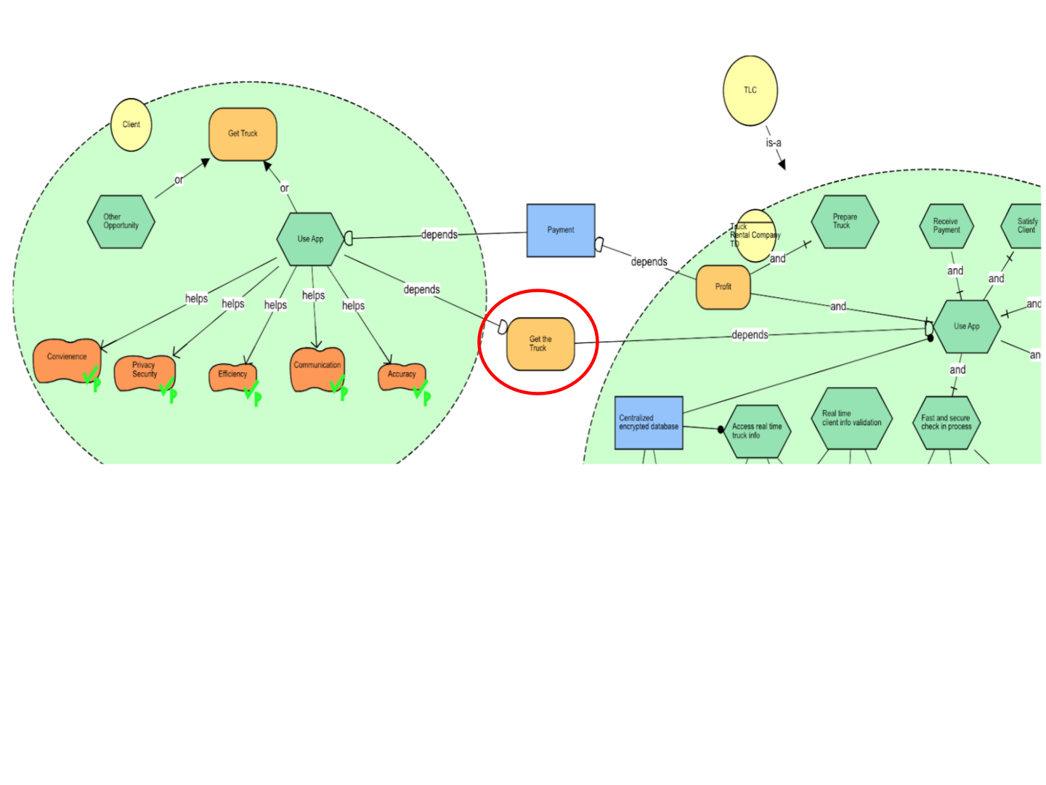

*Figure 3.5: To-Be Alternative One SR*

## Workability

The routine of clients using the app to get the truck is workable since the App can achieve the final goal by answering those following questions successfully. (Figure 3.5)

* 1. Can the App obtain the availability information of trucks and the waiting list once the truck is unavailable?
  2. Can the App maintain secure and confidential information of clients?
  3. Can the App check the validation form automatically and send the notification to clients?
  4. Can the App connect Clients with TD to get a fast response regarding customer services questions?
  5. Can the App send the notification once TD update the time to pick up the truck

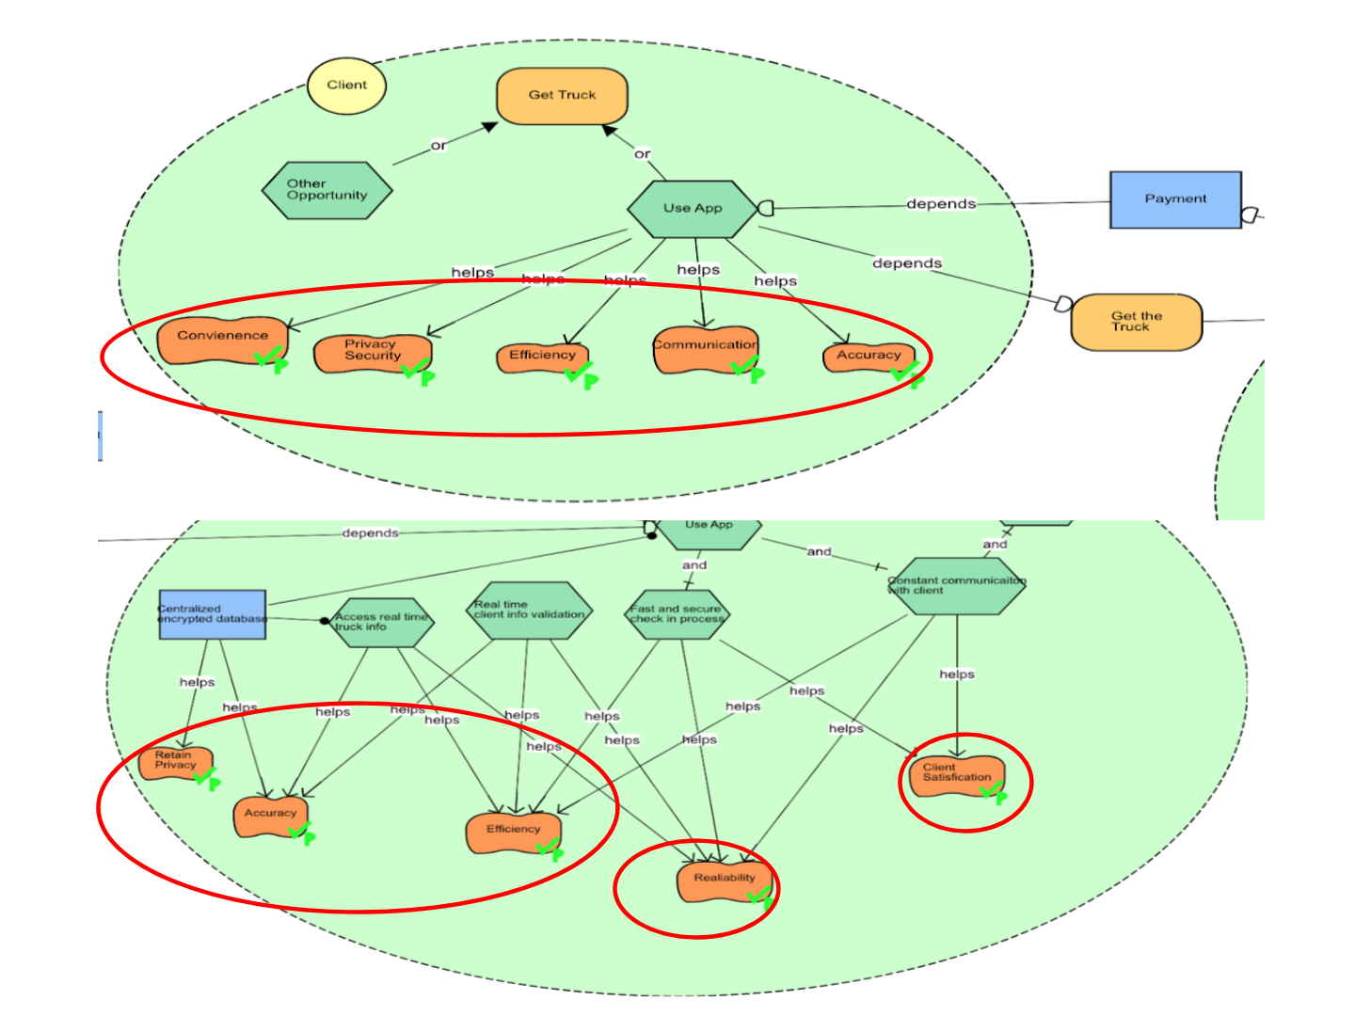

*Figure 3.6: To-Be Alternative One SR*

## Viability

The routine is viable in terms of achieving the following soft goals:

* **Convenience:** The app is readily available, and cross-platform compatible to enable clients get the truck info in a short period of time.
* **Efficiency**: The clients previously had to wait for manual approval, but our App saves the client’s time and effectively eliminate manual work.
* **Private and Secure**: The app provides End-End AES block cipher encryption with SELinx which allows more control to users.
* **Communication**: The app provides real-time communication between clients and the TD, which is also recorded in a database to refer at a later date.
* **Accuracy**: The app eliminates human errors and results in an accurate data flow. It also saves time and resources. It reduces documents (physical and electronic) floating through email.

However, the clients and TD highly depend on the app to achieve soft goals. If the app crashes or faces some technical issues, there will a high risk that soft goals cannot be achieved. Therefore, in terms of propagation of goal satisfaction values in SR models, most of soft goals partially satisfy. (Figure 3.6)

# 3.3 Second Alternative for Detailed Analysis

The second alternative pertains to the creation of a cloud-based web application that makes use of a machine learning algorithm that validates the order form to find any discrepancies or missing information.

## The Process

The client will place an order for trucks on the website and the machine learning algorithm will store the information regarding the client’s order, such as the number of trucks purchased, the quoted price, date of delivery and truck specifications. While filling the order form, if any mandatory fields are left blank or include invalid data, an error will be displayed at run time. When the order form has been successfully filled and submitted, the information will be fed into the machine learning software.

When the order is placed, the algorithm will search the TD Database to find the trucks’ availability as per the enlisted specifications.

The machine learning algorithm searches the database as the client inputs information about their required specifications. If the trucks are available, the client is informed instantaneously. If not, the clients are provided with an estimated wait time until their desired trucks are available. At the time of submitting an order, if the trucks are available then the client is sent a contract for their order which they are required to accept. If rejected, the contract is terminated and the order is cancelled. If accepted, the order is confirmed and the trucks are released to the client.

In order to facilitate repeat business, the machine learning algorithm uses predictive analytics to forecast a particular client’s need for trucks in the coming months. Based upon the information present with TLC about a client’s order and with the help of data mining and predictive modelling, the predictive analysis reports that a particular client had ordered some trucks on the same date at some point in the past. Before sending the report to the client, the database is searched by the algorithm to identify the availability of the trucks belonging to the required specifications. If they are available, the report is then sent to the client to confirm if the same order needs to be placed with TLC again. If the client confirms the order, the trucks are released. If the client does not confirm the order, the report is saved for future reference.

A limitation of this transformation lies in its implementation. In order to establish a machine learning software, TLC would have to hire a subject matter expert or purchase a commercial off-the-shelf product.

# 3.4 Detailed Analysis of the Second Alternative Using i*

## SD Representation of 2nd Transformation Alternative

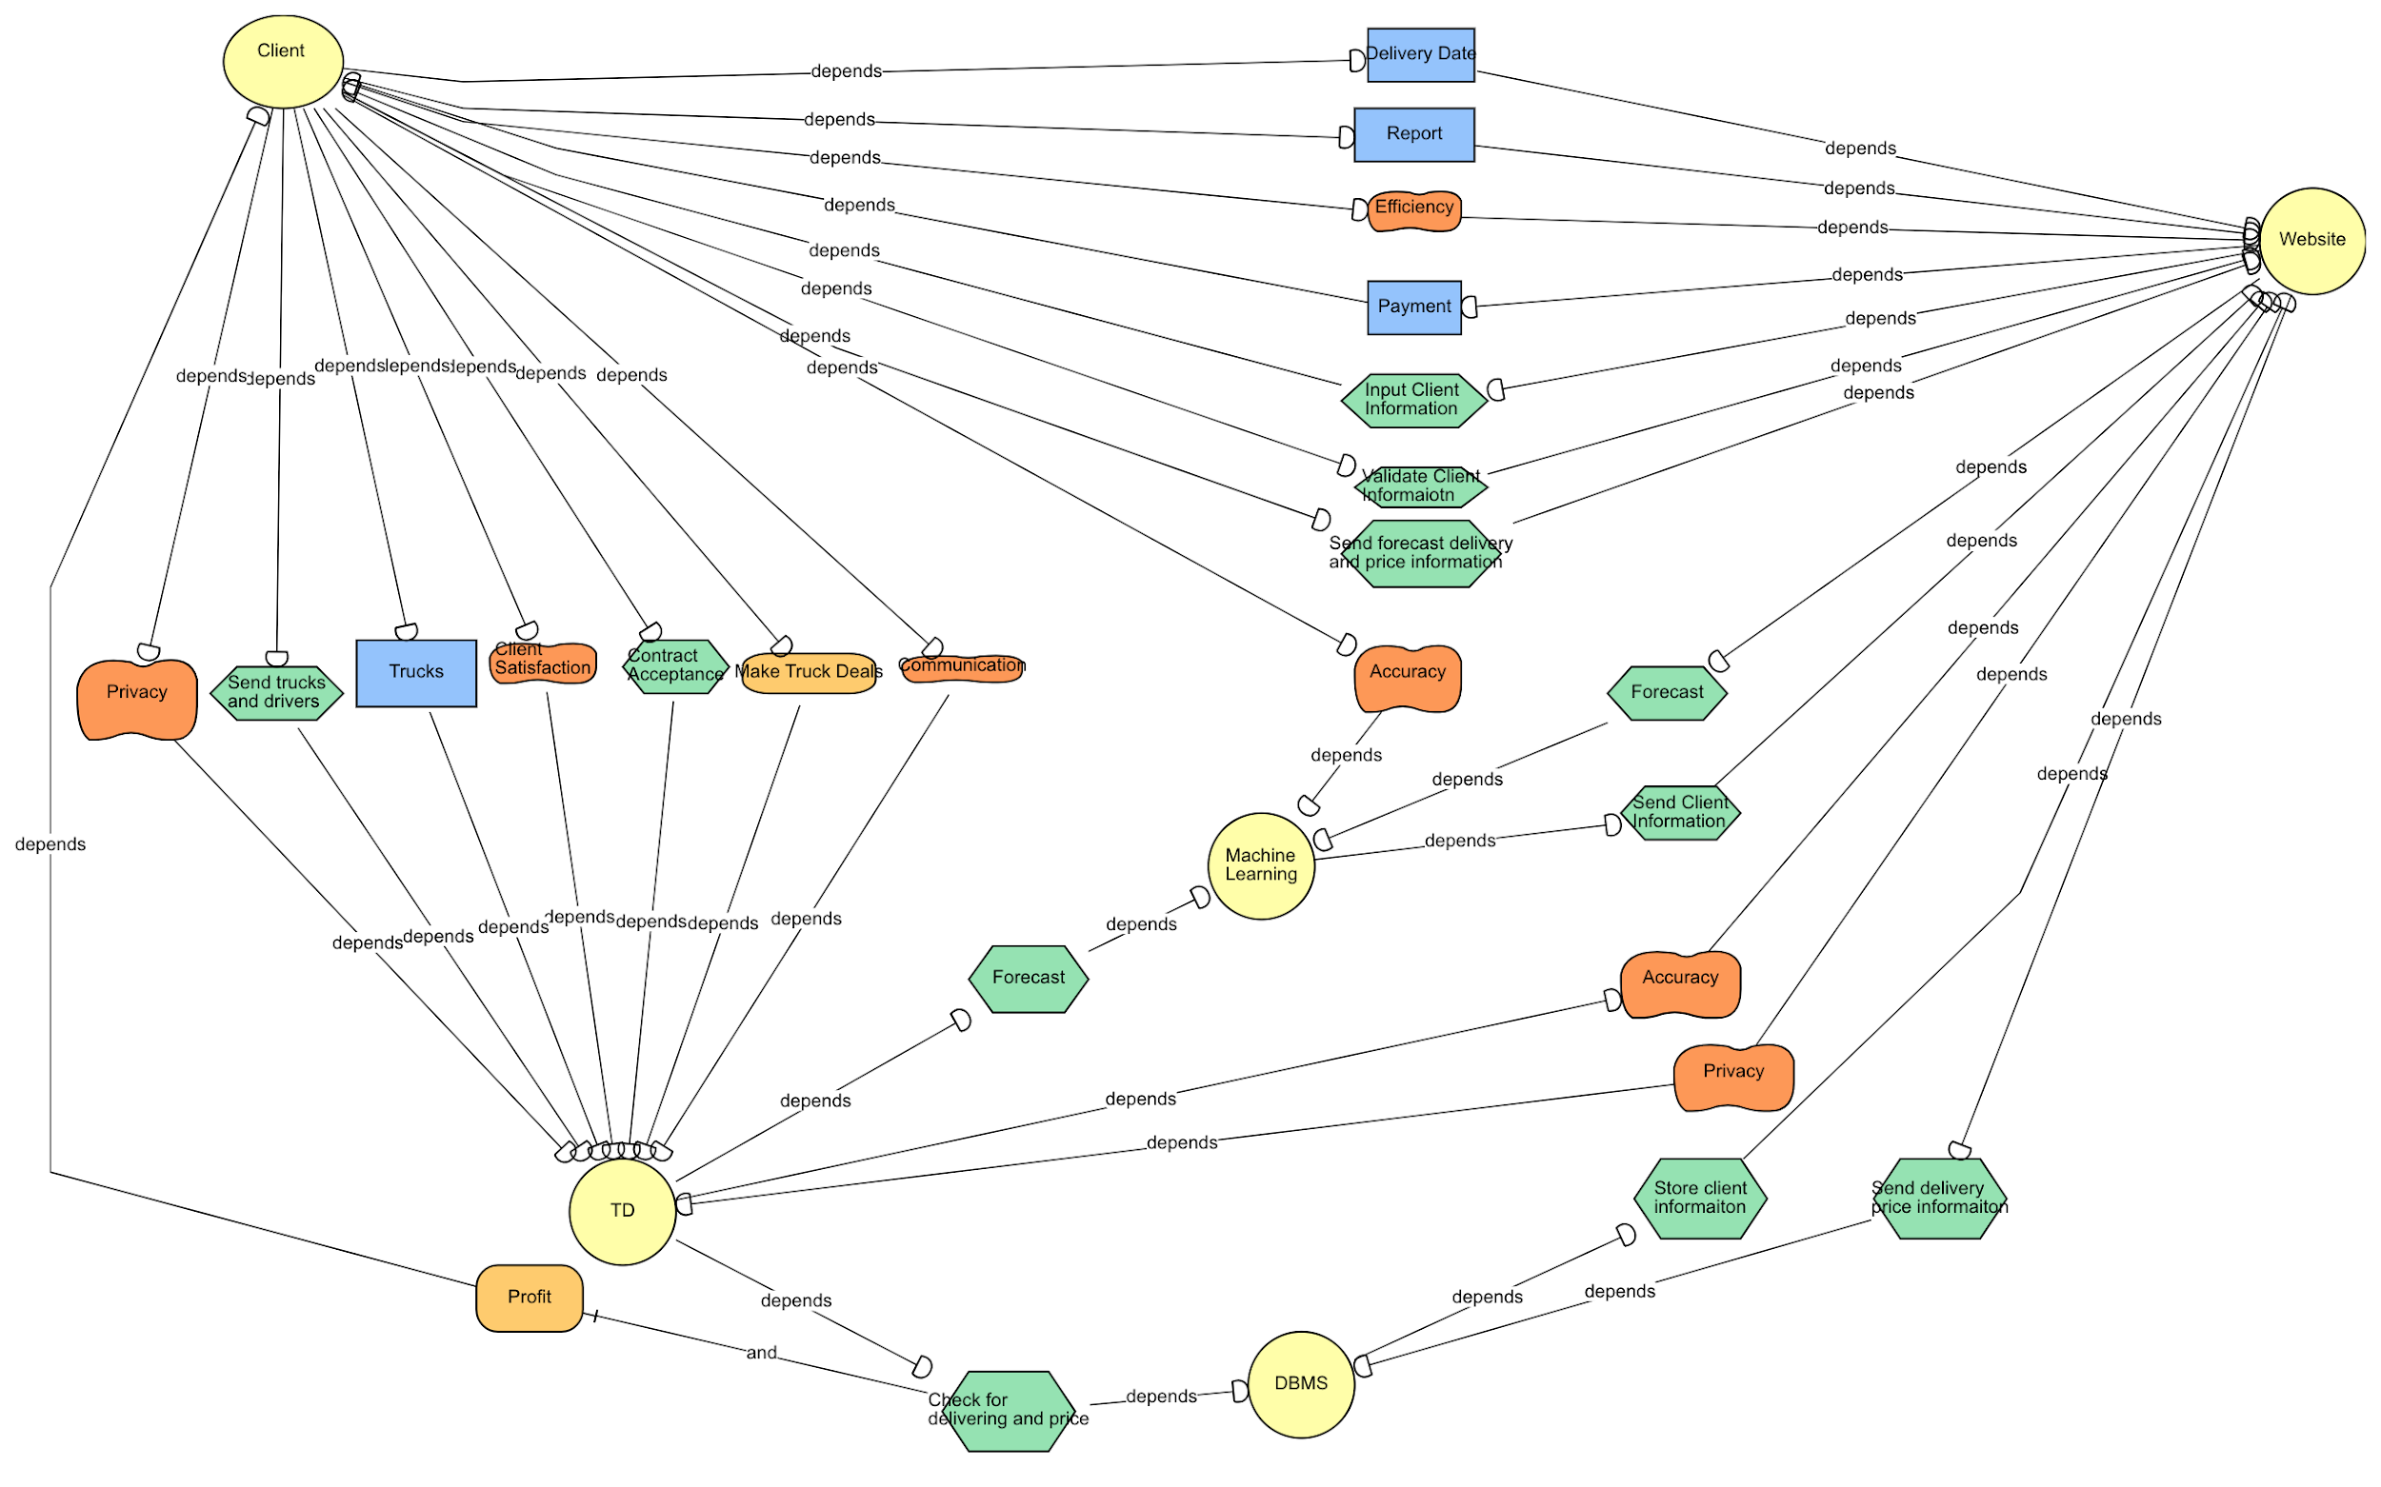

*Figure 3.7: To-Be Alternative Two SD*

## Analysis of SD Diagram

In figure 3.8, the main tasks between client and website are providing client information, validating the said information and forecasting the delivery and price information. The client accesses the web application to place an order for trucks. As the client is providing the said information through the form, the entered details are authenticated by the machine learning algorithm. If any issue is observed, the order form is not submitted and the client receives an error. In the interaction between the client and website actors, payment, delivery date and report are the resources. The website is dependent on the client for the payment of truck services and the payment resource enables the transaction to go through. The client actor depends on the website actor to receive the report that is generated by the machine learning algorithm which, in turn, uses predictive analytics. In the report, TLC Trucking reminds the client that they had placed similar order around a particular date and whether they would like to do that again or not. The client actor is also dependent on the website actor for the delivery dates of the trucks; a dependency that is met through the help of delivery date resource.

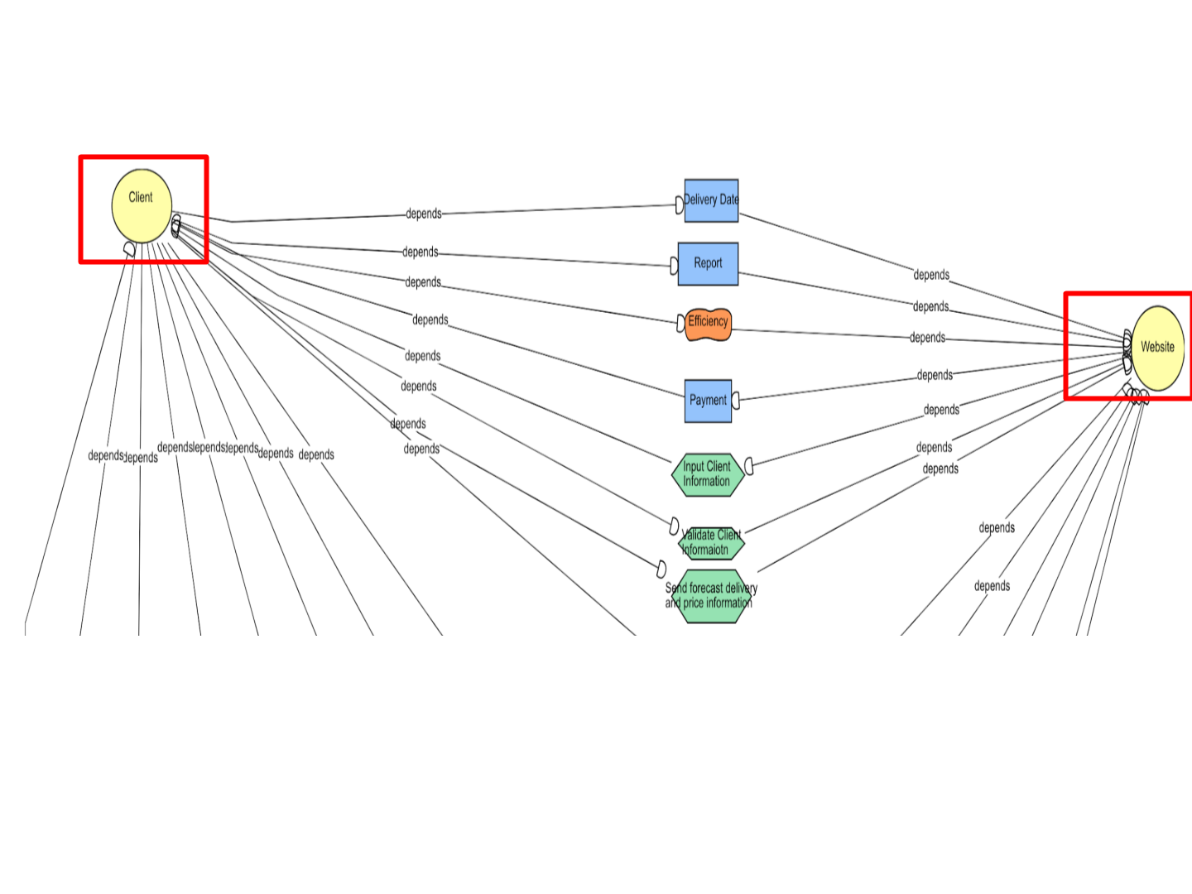

*Figure 3.8: To-Be Alternative Two SD*

The soft goal(figure 3.8) is the efficiency of the process, satisfied by the way the website sends instant responses to erroneous areas in the order form so the client knows what went wrong with the order submission. Also, the information about trucks availability is provided at runtime for the client.

The relationship between Client actor and TD actor involves two main tasks; sending trucks and drivers for which the client is dependent on the Transport Department (TD) and acceptance of contract for which the TD department is dependent on client’s acceptance.

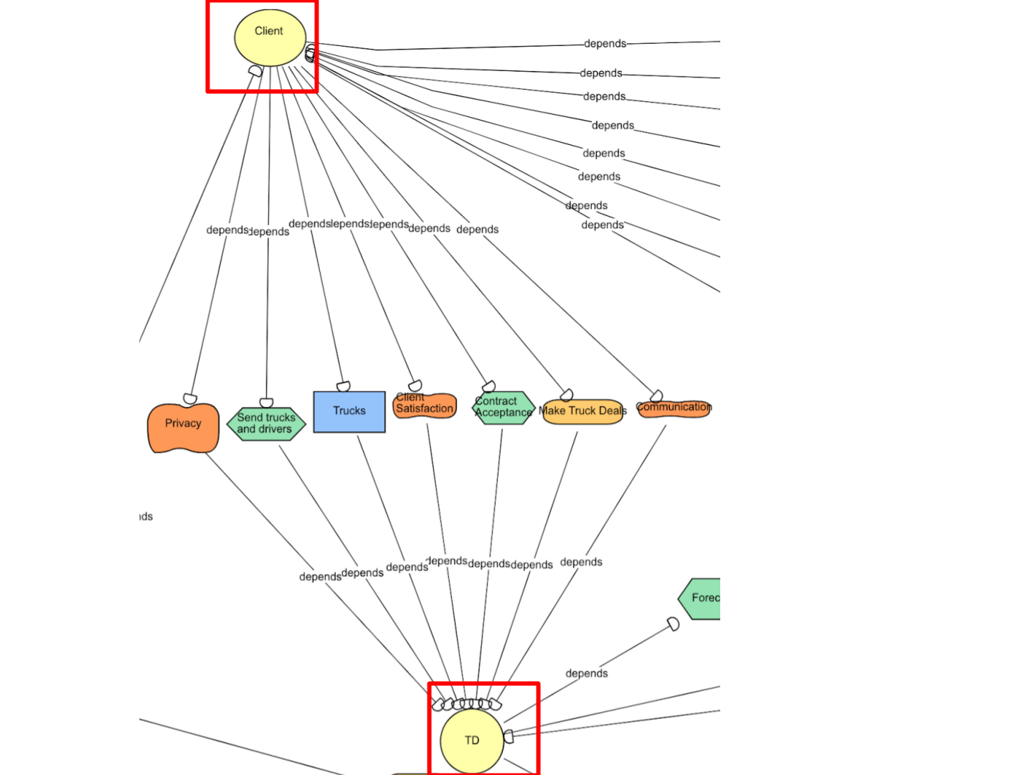

*Figure 3.9: To-Be Alternative Two SD*

The three soft goals (figure 3.9) are satisfied here in the following ways:

* **Privacy**: No email exchange occurs between different departments, which avoids the potential of a leak of a client’s confidential information.
* **Communication**: The Information transfer about trucks availability from the TD database to the client is quick. This ensures client’s wait time. is reduced.
* **Client Satisfaction**: The quick, efficient process of truck booking along with the responsive nature of the website assists the client in placing an order and thus contributes towards overall client satisfaction.

The Website actor and machine learning actor(figure 4.0) have two tasks in their relationship: a forecast which is done by the algorithm and sending client information to the website, which can then prepare a report and send that to the client.

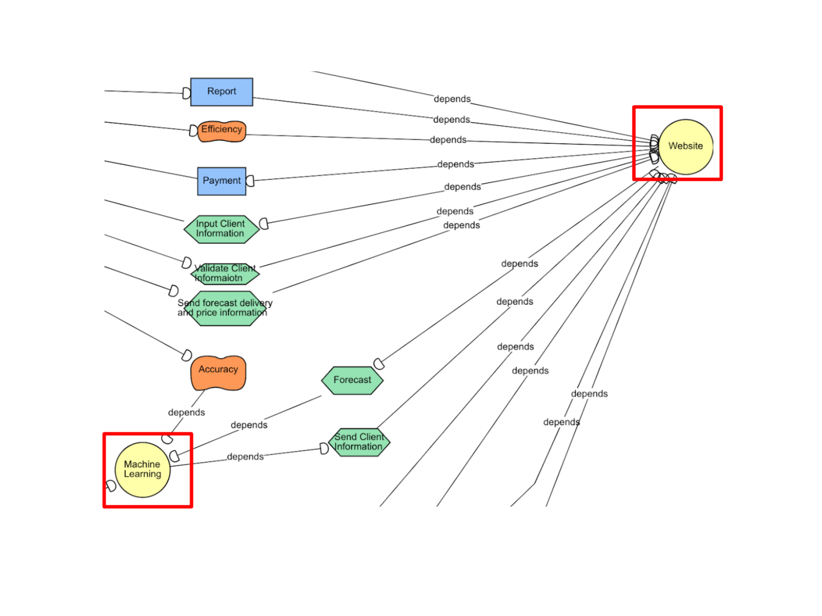

*Figure 4.0: To-Be Alternative Two SD*

The TD actor and DBMS actor (figure 4.1) have one task which is to check for trucks delivery and price. The TD is dependent on the DBMS for this activity as the response from DBMS is then relayed to the website through the TD.

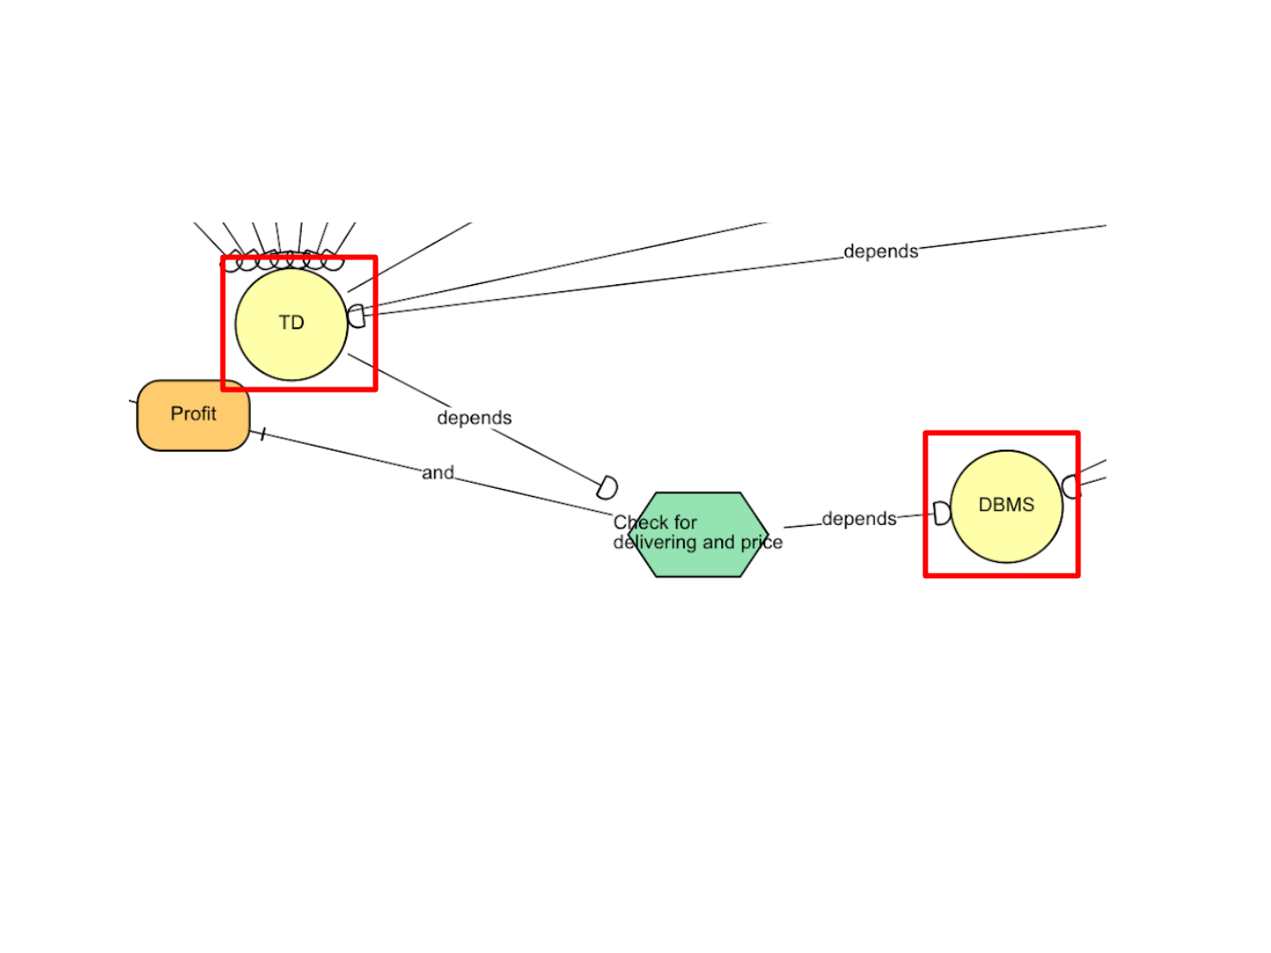

*Figure 4.1: To-Be Alternative Two SD*

There’s one task between TD actor and machine learning actor (figure 4.2) which is forecast which uses machine learning predictive analysis to forecast a client’s future order. Therefore, the TD is dependent on machine learning for executing this task.

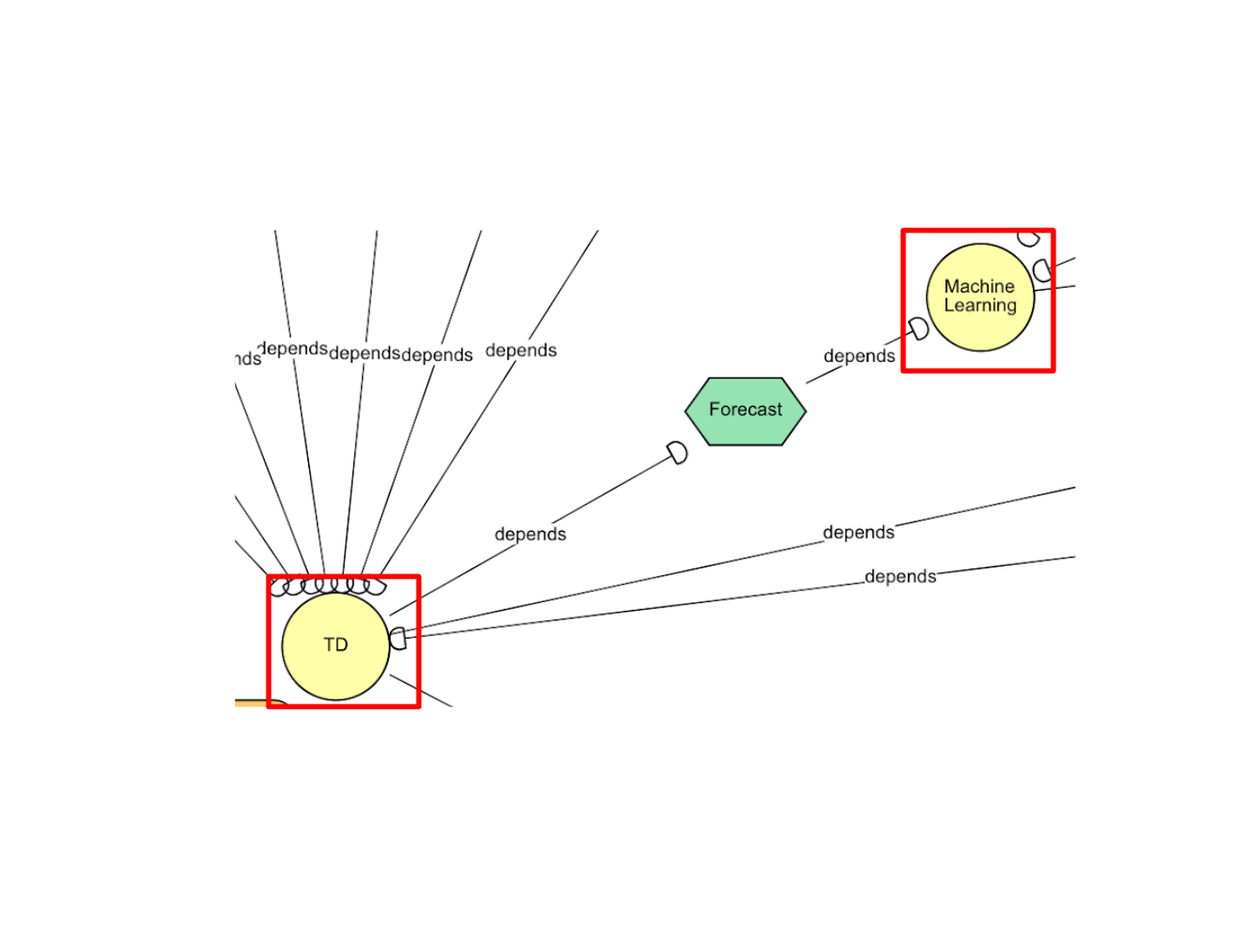

*Figure 4.2: To-Be Alternative Two SD*

The Website actor and DBMS actor (figure 4.3) have two tasks in the relationship: storing the client information and sending the price information to the client, for which the website depends on the DBMS actor, as the price and trucks availability are stored in the DBMS tables.

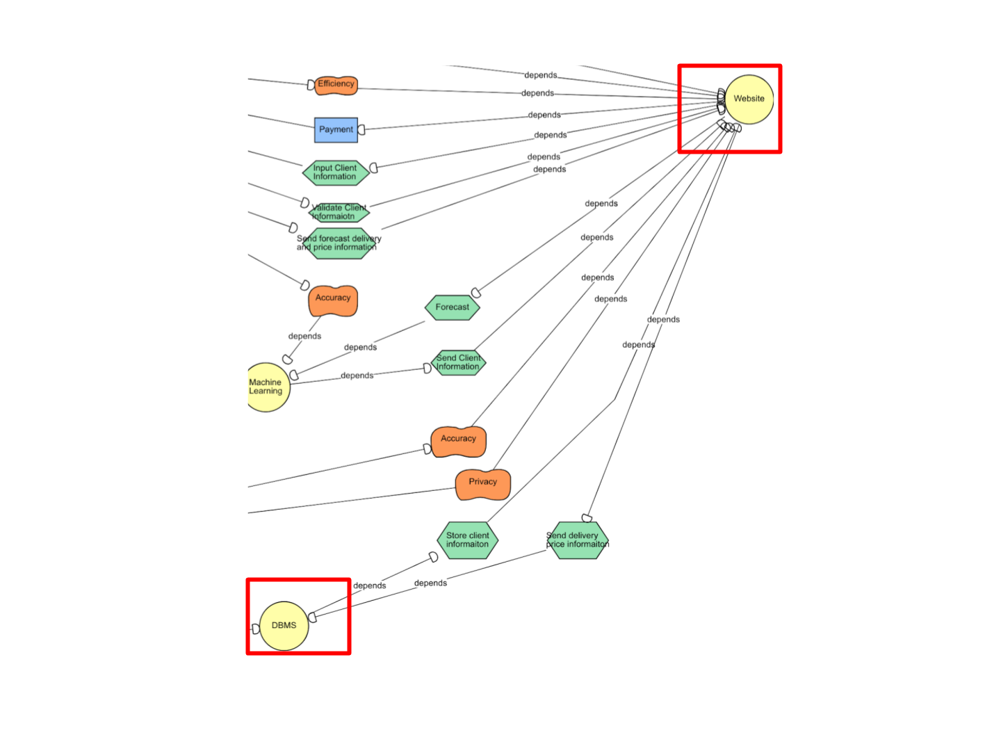

*Figure 4.3: To-Be Alternative Two SD*

The two soft goals between website and TD(figure 4.4) are accuracy and privacy. The TD depends on the website to provide it with valid information about a client before the TD can interact with the DBMS. The website, in turn, depends on the TD actor to secure the privacy of the client by storing the information in the database without any data breach.

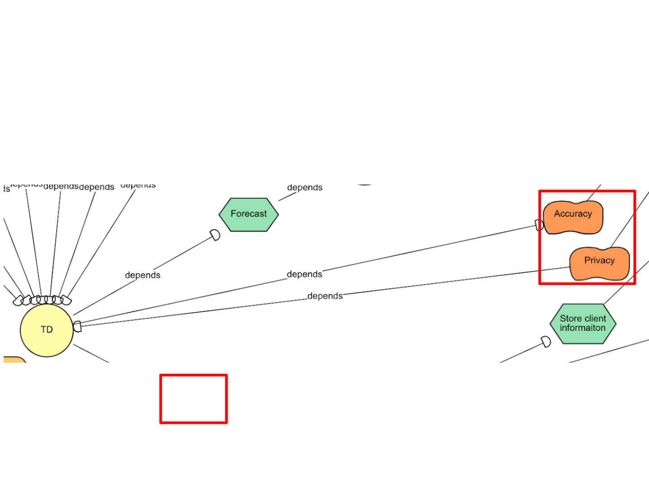

*Figure 4.4: To-Be Alternative Two SD*

## SR Representation of 2nd Transformation Alternative

If we further analyze the second transformative idea with the aid of the strategic rationale (SR) model as shown in Figure 5.0, we can get a clear delineation and are able to justify the proposed idea. 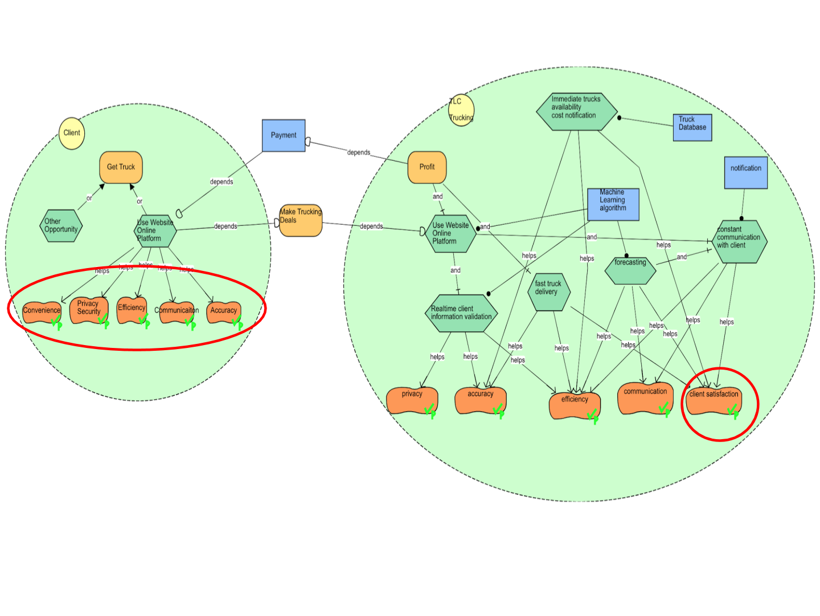

*Figure 5.0: To-Be Alternative Two SR*

The SR model is analyzed from perspective of separate actors and their respective environment. It is modelled by comparing whether and how their soft goals are met. It should also be noted that the soft goals for each actor are mostly common with exception of one.

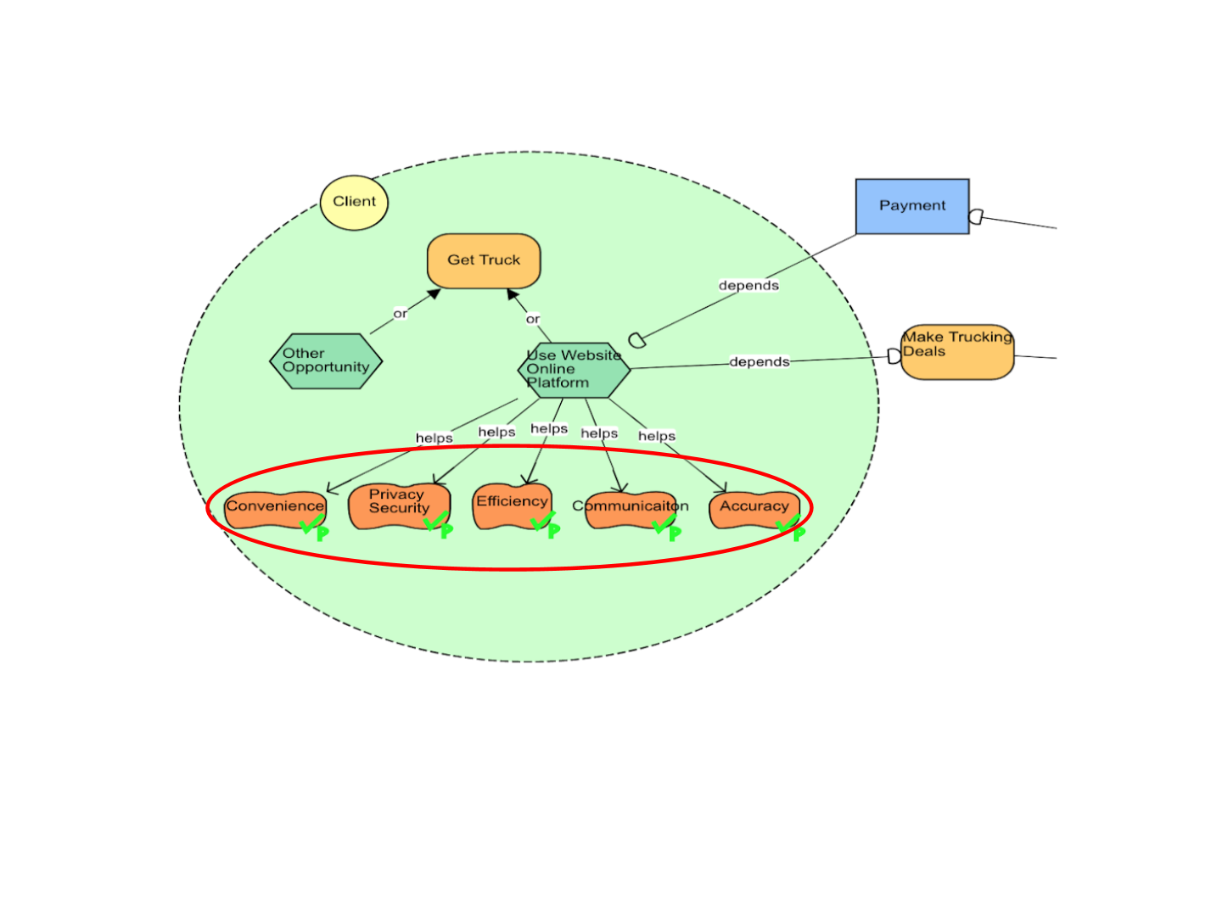

*Figure 5.1: To-Be Alternative Two SR*

When the client accesses the web application to place an order for trucks, the following soft goals are considered (Figure 5.1) to measure how the proposed idea is aligned with the client’s expectations. The soft goals for the client are as follows:

* **Convenience**: The website is an online platform which is readily available from smart devices with an internet connection. It helps the customers avoid the hassle of printing, manual form completion and submitting the scanned copy thus saving time.
* **Privacy & Security**: The information uploaded into the website would be end-to-end encrypted, ensuring secure data transfer.
* **Efficiency**: The whole task is processed over the internet, considerably reducing the time taken to perform each task. In addition, the machine learning feature would assist customers in making the right choice of vehicle for shipping their products. Proactive suggestions and automated reminders would help clients manage their requirements stress free.
* **Communication**: System sends update in real time, thus improving communication and curbing the wait time. This helps as the wait time and the response time between the company and the customers are happening in real time.
* **Accuracy**: Information that is uploaded and retrieved online is less prone to human error. Furthermore, the machine learning-generated forecast will have a reduced margin of error in computation in regards to the wait times of unavailable vehicles. The client’s leasing cost estimate will be accurate as well, as the calculation would be computed by the software.

Soft goals of TLC Trucking is almost similar to their own justification except for one where the company majorly focuses on client satisfaction rather than convenience (shown on Figure 5.2). The following soft goal is measured from the perspective of TLC Trucking:

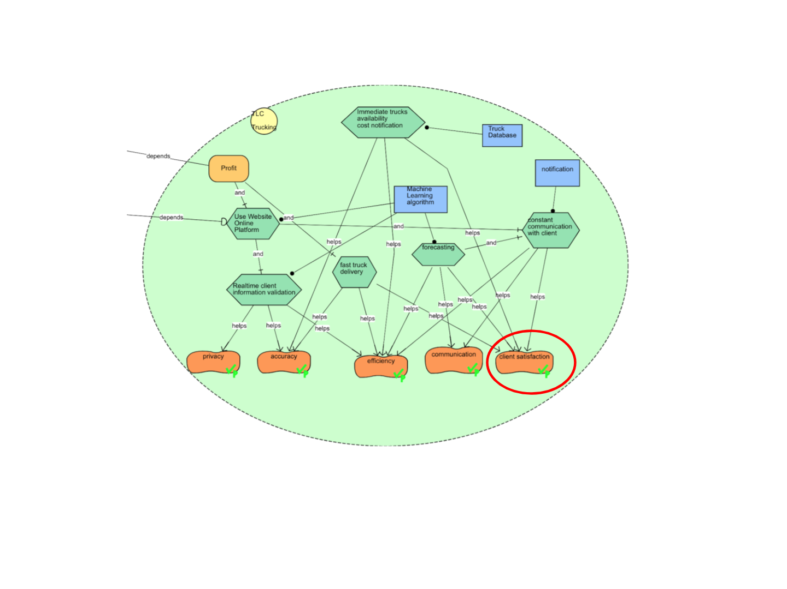

*Figure 5.2: To-Be Alternative Two SR*

* **Client Satisfaction**: This is one of the major objectives of the company. Client satisfaction would be ensured as a result of taking steps in ensuring all other goals are met and this helps the company by ensuring the clients are turned into regular customers thereby maximizing the business.

# 4. Comparison of the Two Alternatives

Our first alternative (the app) has three actors, but our second alternative (the machine learning-based logistics website) has five actors. Right away, one senses a greater complexity to the website-based alternative. In the first alternative, the client is only depended on for accurate information. But in the second alternative, the client is depended on for profit and payment as well as their own information. This further suggests a greater complexity to our second alternative, which might make that system harder and costlier to implement or fix if things go wrong.

In the first alternative, the client’s dependencies are much more often related to soft goals, which suggests that the app is a change that has been done more for the client’s sake than anyone else’s. The emphasis is on enriching the client’s experience, rather than easing things up for the company.

Both the app and website are heavily depended on in their respective systems, but the website has a few more dependencies of its own.This suggests that the first alternative’s app presents a more centralized point of failure (and thus a larger risk to the integrity of the system) than the second alternative’s website.

The first difference one notices when comparing the SR diagrams between the two alternatives is the hard goal between the client and truck company. On the App it’s “get the truck,” while on the website it’s “make trucking deals,” a subtle discrepancy in wording that has big implications. “Get the truck” is simpler, referring to the selection and securing of the truck via the functions of the app. Meanwhile, “make trucking deals” suggests a goal of persuading the client to get trucks they otherwise would not have gotten. (“Don’t merely get *this* truck, but get this deal for future trucks as well.”) From the company’s perspective, this is a point in favour of the website. However, the website is also more resource-intensive. It requires not only a database of the trucks, but the technology needed to make notifications (perhaps by phone, email, or mail) and a machine learning algorithm. The App only asks for the database.

The App includes more tasks, and more manual actions from the human actors at TLC Trucking. This could be good or bad depending on one’s perspective. The machine learning algorithm better automates the tasks, which should get things done quicker, but the app allows for a more human connection between the company and the client. Take a look at a task that appears on both alternatives: “constant communication with client.” This is achieved in alternative two with machine-generated notifications, but on the App this communication comes in the form of human-answered questions via the app. The trade-off to be considered is efficiency versus a certain type of human-centered service that machine learning can’t provide.

Finally, the way in alternative two that we have connected the hard goal of “profit” to the task of “fast truck delivery” suggests that speed and efficiency is a real driving force behind the design of the website. It suggests that a competent but slow truck delivery stands in the way of profit, because (it is suggested in the chart) that a client will take their money elsewhere if the truck delivery is not “fast.” Here is an example of where one would need to conduct customer market research to know the true priorities of the clients in the area. One can imagine an area where speed is considered king–and where alternative two might provide the expected efficiency–versus an area where service and perhaps the cost to the company (after all, the machine learning algorithm would not be cheap) is more important, and thus the App might be preferable. There does not appear to be a unanimous winner in terms of which alternative is best–it is dependent on the local context of the company office.

# 5. Comparison of Process Alternatives from Assignment 2

# 5.1 Description of Process Automation Alternatives

There are three main parts to the truck rental process, namely, form submission, rent quotation, and internal communication between two divisions of TLC Trucking. To address the shortcomings in the current as-is process, we came up with few alternatives:

* **Online Form**: The client can enter their details and the truck specifications via the online form. The form will include mandatory fields which until filled will not process further. The form will prompt the user to fix any information that has been entered incorrectly (e.g. too many characters or symbols where something should be alphanumeric). As for the truck specifications, there will be a list from which the customer can choose. This will aid in faster response as the CDM department will not have to spend days to verify if the manually written specifications are correct or not.
* **Online rental quotes**: To assist the customer in making an informed decision in the early stage of the process, an estimated cost of the truck based on the specifications will be displayed on the online form. The client may then decide to go ahead with same order or perhaps update the trucks.
* **Document upload at internal source**: Using an internal source where the document is uploaded and is accessed only by members of CDM and TD department will prove to be beneficial. TD can process data and provide updates to the client faster.

# 5.2 Goal Model-Based Analysis of Automation Alternatives

*Figure 6.0: Goal Model of Process Automation Analysis*

This goal model helps us to understand how the process and the proposed alternatives can aid in achieving the objectives or the soft goals.

The task of making a profit for the business is achieved by the three components of the process–form submission, rent quotation and data transfer between two departments. Form submission and receiving the quotes can be achieved by either the current email-based system or the suggested online form.

The soft goals for this process are automation, efficiency, accuracy, secure information, and client satisfaction. Both automation and efficiency are components of “effective work process” which is achieved when either automation or efficiency is satisfied. For the soft goal of “information integrity,” both accuracy and security should be met.(Figure 6.0)

The current system falls short and hurts all the soft goals. The as-is system, which uses both paper and email-based communication, hurts the soft goal of automation because it must be done manually by human employees. Additionally, this is inefficient because each document, whether digital or otherwise, must be dealt with one at a time. Accuracy is threatened because the employee must rely on their own knowledge when responding to a client; in reality, nothing is preventing an employee from accidentally spreading erroneous information. Finally, this system fails our soft goal of information integrity because, especially in the case of the paper documents, unauthorized actors can read or copy personal, private information.

On the other hand, if an online form submission is implemented, the client data can be validated simultaneously, and the client can view an estimated pricing for the rental. We can achieve this by having different database system in place that query the databases and performs validation. This will enable in an automatic and efficient data validation, saving processing time. Since the data is validated online, and there is limited involvement of CDM department in validation, the details are secure and highly accurate, overall making the process easy to follow and providing higher client satisfaction and thus helping us achieve all the soft goals.

# 5.3 Description of Process Innovation Alternatives

* **VoIP**: This alternative can be selected when the communication over emails consumes a lot of time or the email server is down. There are instances where in the inbox is not synced that also leads to a lot of wait time in responding to emails. In this case, TLC can communicate through Voice over Internet Protocol. Even when the email server is not down, the introduction of VoIP PBX phone systems might enhance communication between TLC Trucking departments. Phone calls carry an inherent sense of urgency that emails do not; they cannot be ignored in the same way that emails can.
* **Notifying client on trucks availability**: This alternative can be selected when the required trucks for a client’s specification are not available. Clients are notified about the waitlist and are then notified again when the trucks are available. The client is notified via the website and also in addition an email will be sent. This alternative improves the order handling process, enabling less time spent in the manual processing of the applications.
* **Accepting quote online**: Instead of sending and receiving hard copies of signed the quote, this alternative can be chosen to not only speed up the process but also secure the client’s privacy. The transportation department will assume responsibility for checking truck inventory and notifying the client through an automated message.Online offer acceptance, helps in secure data transfer, reduction in human errors and helps TLC to use their resources wisely.

# 5.4 Goal Model-Based Analysis of Innovation Alternatives.

# 

*Figure 7.0: Goal Model of Process Innovation Analysis*

The lack of automation and innovation for this company results in time-consuming processes that interfere with overall productivity. Manual communication and online based information system plays an important role in the whole process to make profit.

The online based information system will process the request, check for available trucks, add clients to waitlist, and notify clients with cost once the requested truck is available. The information system allows client to submit and accept offer online. In comparison, the as-is process manually checks client’s information from the DBMS. The online system will reduce the overall time spent from both the client’s and TLC’s side. Clients don’t need to manually correct application information. Fewer employees will be involved in the truck ordering process. As a result, these two selected alternatives improve TLC’s work efficiency, client’s data security, and order information accuracy.

Communication is limited within TLC to only receiving and providing forms. Although the as-is email communication is good for record keeping, the email server can crash and the accuracy and security of the communication will be harmed. The VoIP alternative could enhance communication between the departments and the clients. Improved communication means improving efficiency and effectiveness while performing the process. VoIP saves email response time and minimizes the manual work involved. However, even the VoIP system has the risk of computer viruses that may hurt or break the communication’s security and accuracy. All in all, the three possible to-be alternatives partially satisfied the soft goal of client satisfaction. This would somewhat help the CDM provide information about the truck availability and the estimated time of wait.(Figure 7.0)

The alternative of notifying clients about trucks availability or their waitlist period when they submit their online order is preferred as it accelerates the process of relaying information to the client by reducing the manual tasks. In the as-is process, after a client submits an order, the process relies on the CDM to manually query the database and look for the availability of trucks corresponding to client’s specifications. The entire process includes an exchange of high number of emails between multiple departments to carry the information from client to the TD and back. With this existing business flow, the cycle time for the process is significantly high as communication over emails and manually querying a database is not only laborious but also time-consuming and opens the risk to human error.

With the aforementioned alternative, a lot of risk dependencies are minimized and, at some places, completely obliterated.

To begin with, a client does not have to wait for a long period of time to understand the status of their order. If the trucks are available, the client is notified at that instant. If the trucks are not available, a notification is provided to the client about an estimated wait time. This provides a lot more control to the client to decide whether they would like to wait for their order or not.

Secondly, the alternative reduces the amount of manual tasks (such as the exchange of emails), which directly enhances the efficiency of the system. With a reputation of being an efficient system with a fast response time, TLC Trucking can capitalize on a high client satisfaction ratio by establishing future business with the same client. This paves the way for a sustainable business model.

Thirdly, with a system that does the work of a human resource, the susceptibility of the risks with respect to intangible factors like an employee’s state of mind or bad health are circumvented. This directly affects the accuracy of the output which in this case refers to correctly identifying the availability of the trucks or calculating the wait time for the client.

# 

# 6. Comparison of i* and Process Modeling Techniques

# 6.1 Comparison of Techniques in the Context of the Case Study

|  |  |  |  |  |
| --- | --- | --- | --- | --- |
| **Comparison** | **SD** | **SR** | **DFD** | **BPMN** |
| **Use in the case study** | -Understand dependencies and the reasoning behind their tasks.  -It made it easy for us to understand the client's’ objectives and how they are affected by the process.  -It helped us understand how our alternatives differed from the as-is process in regards to task flow and the dependencies of the new actors. | -The SR helped us understand understand if the tasks done by each of the actors make/help/hurt their goals. Doing so helped us understand what part of the process needed to be improved.  -The SR helped us understand how the alternatives impact the soft goals and how the new tasks helped with meeting the company goals. | -DFD helped us understand the process from a data flow perspective.  -It explained in detail the process the company uses to record and save the client-provided data. | -BPMN explained the activities performed by each department and understand how the departments work together to perform the business.  -It helped us understand how the new ideas improve the process. |
| **Flows** | SD uses a set of nodes and links. Each of these nodes represent an actor and each link between the actors determine the dependencies between them. | SR uses four types of nodes based on SD and what it represent. The main links used are task decomposition and means-ends. | DFD showed the flow of data in the company’s information system. | BPMN uses symbols to clearly illustrate the flow of the business process. |
| **Advantages** | I* helped us to identify and prioritize the company’s goals. It facilitated thinking about actors’ motivations.  It was easy to break the system down into small components to analyze them which helped to look at the gaps in the process and come up with ways to improve them. | | DFD provided us with detailed representations of the process entities and components.  It was easy to understand the flow of data between the entities and understand the technical part of the process as it showed what was needed for the data flow. | BPMN helped in managing the business process by elucidating the activity of each department and how they interact and communicate.  It is easy enough for a layman to understand the activities performed by a department. |
| **Communication** | Easy to understand the process by knowing the dependencies, why tasks are performed and what are the goals behind these tasks.  Although helpful, it was hard to follow and create. | | Helpful to understand the data flow, but it was hard to follow the process because our process was long.  Unlike the i* model it doesn't show us the motive behind these activities. | Helpful in understanding the activities and easy to follow but unlike the i* model it doesn’t show us the goals and the motive behind these activities. |
| **Understanding and details** | Understanding the dependencies and what tasks should be added/removed to come up with new ideas that meet the goals was a particular challenge. | | It was difficult to understand, but less complicated than i* because it was hard to know which tasks are considered at 1st and 2nd level.  It was very complex as we have to look at all the tasks and know the data flow. | Easiest model to understand.    It was detailed, as it showed all the steps in the process, but it was less detailed than DFD and i*. |
| **Disadvantages** | Creation of the model was tedious and very time consuming. We found it very difficult to explain the diagrams to a layman. | | DFD can’t show all the detailed information in our database because there are only the data store symbols in the diagram.  DFD doesn’t explain why each activity or data flow is performed. | When when there are multiple interactions between the departments, it becomes difficult to follow all the activities in the process.  BPMN is considered to be a flowchart and it can’t model complex adaptive systems. |

# 6.2 Strengths and Weaknesses of i* in the General Case

## Strengths

I* provides the strategic perspective on organizations by determining the main actors, relationship, dependencies, main tasks and goals. I* facilitates thinking about actors’ motivations in addition to their goals. By using i* modeling, our team began with a process of an actor (client) achieving their goal (get the truck) by determining the main tasks, and then identifying internal and external dependencies, soft goals and resources. This provides an overall structure of process involving all the possible details to achieve the final goal.

I* also helps in identifying and prioritizing the company’s goals and is well suited for collaboration between a team of stakeholders to generate a new solution. In our case, the main goal of the company is to make profit, for which i* shows the clear goals to be achieved, tasks to be performed and resources to be furnished. From the as-is SD/SR diagram, we could clearly understand the opportunities and vulnerabilities of the process. Based on that, our team generated two transformation ideas to help the company solve the challenges by achieving actors’ soft goals.

I* modeling provides an easy way to break the system down into individual components and analyze them. Based on the evaluation and analysis of our i* models through lenses such as ability, workability, and viability, our team deeply analyzed every possible routine for actors to achieve their goals. Based on the evaluation of each element and step in SR/SD diagram, we adjusted our to-be alternative with more detailed information and an effective way to achieve the goal.

## Weaknesses

Creation of models is tedious and time-consuming since i* tools such as OpenMe are extremely unfriendly on Macbook. It took a long time to figure out how to correctly install the software. Then we decided to switch to another i* tool, Leaf 2.0. However, it was hard to keep the SR/SD diagram readable when lines tend to cross over. It was hard to change one element or dependencies and keep the diagram readable at the same time, so it took us a long time to redraw the diagram. In addition, the software was unreliable because the dependency lines were disabled to connect and sometimes displayed the incorrect dependencies. No matter which i* software we tried, we had problems.

In addition, it is difficult to explain the diagrams to a layman as i* modeling has complicated concepts in both SR/SD diagrams, including the differences between actors, agents, roles and dependencies. During our process of generating SR/SD diagrams, we found out even team members who already had knowledge about i* models had a different understanding of the applications of SD/SR diagrams.

# A Note On Why We Chose This Topic

Reading the TLC Trucking in assignment 2, we found it better to continue to use the process in assignment 3. The process was clear and we found good potential to find transformation ideas which helped us create the i* diagrams. In addition to this we found the automation and innovation ideas from assignment 2 easy to understand and easy to create the goal diagrams.

# 7. References

Eric, Yu (n.d.). I* wiki. Retrieved December 11, 2018, from http://istarwiki.org/

Eric, Yu. Strategic Actors Modeling for Requirements Engineering - the i* framework

[PDF document] Retrieved from http://www.cs.toronto.edu/km/istar/istar05-London-tut.pdf

Session 1 - Introduction [PowerPoint slides]. Retrieved from Lecture Notes

Online Website: http://www.cs.utoronto.ca/pub/eric/tut1.2-v2.ppt